**Practical 2**

**To implement Various Hadoop HDFS Commands**

Commands:

1)hadoop version



2)hdfs dfs -ls /3)hadoop fs -ls /

4)hdfs dfs -mkdir /rjcit2122

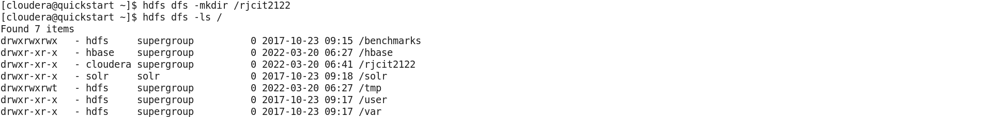

5)Create folder on desktop



6)create file in desktop folder

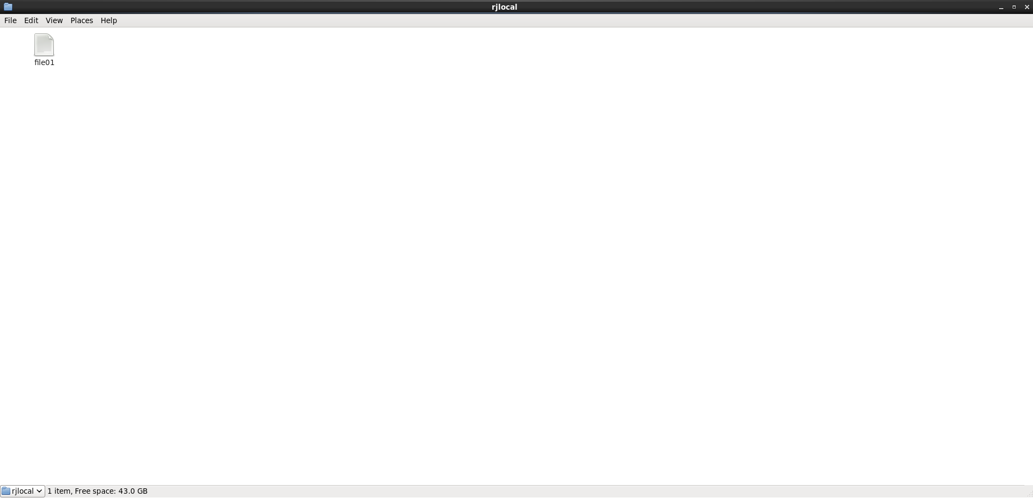

7)Enter some text in the file

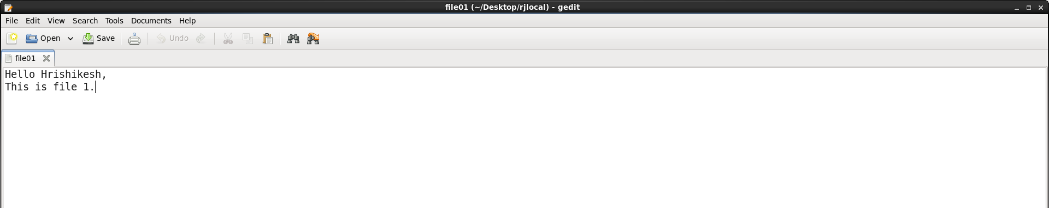

8)hdfs dfs -copyFromLocal /home/cloudera/Desktop/rjlocal/file01 /rjcit2122

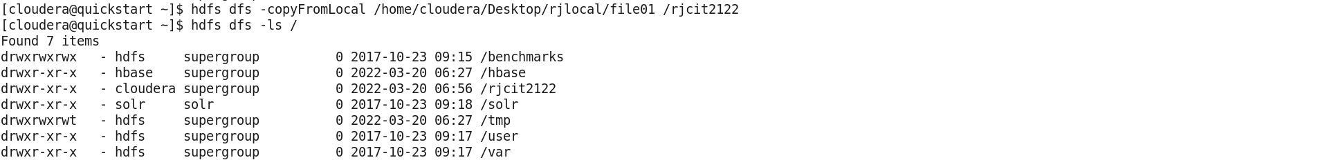 

9)hdfs dfs -put /home/cloudera/Desktop/rjlocal/file01 /rjcit2122

🡪 (Copy Local To Server)



10)hdfs dfs -copyFromLocal /home/cloudera/Desktop/rjlocal/file02 /rjcit2122

🡪 (Copy Local To Server)



11)hdfs dfs -copyToLocal /rjcit2122/file02 /home/cloudera/Desktop/rjlocal

🡪 (Copy Server To Local)



12)hdfs dfs -cat /rjcit2122/file01 🡪 (Read command)



13)hdfs dfs -cp /rjcit2122/file02 /newdir 🡪 (Copy command)



14)hdfs dfs -mv /rjcit2122/file02 /newdir1 🡪 (Move command)

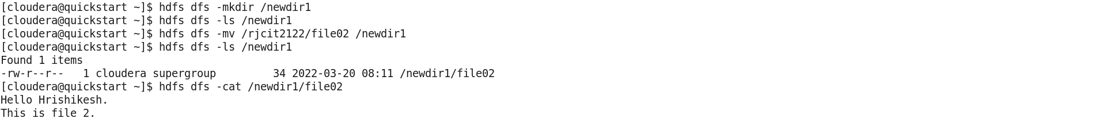

15)hdfs dfs -rm /newdir2 🡪 (Remove command)

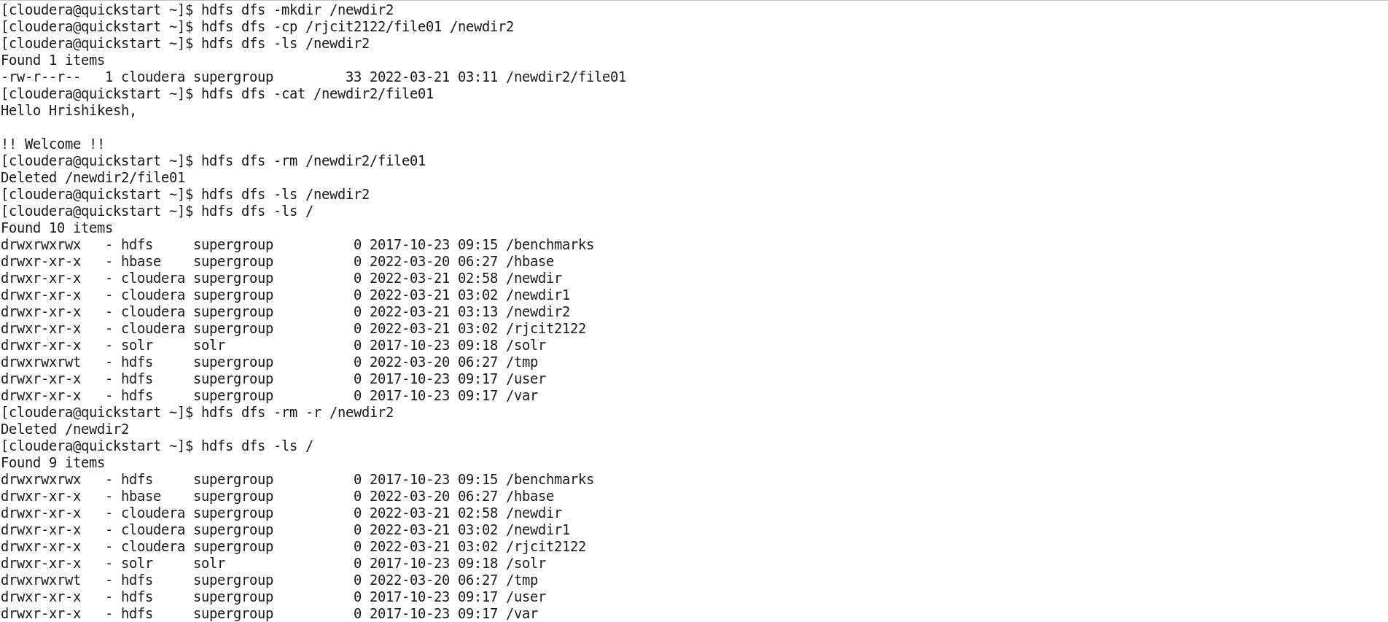

16)hdfs dfs -expunge 🡪 Expunge Command (Empty Trash)



17)hdfs dfs -du /rjcit2122 🡪 DU Command



18)hdfs dfs -df 🡪 DF Command



19)hdfs fsck /rjcit2122 🡪 Fsck command

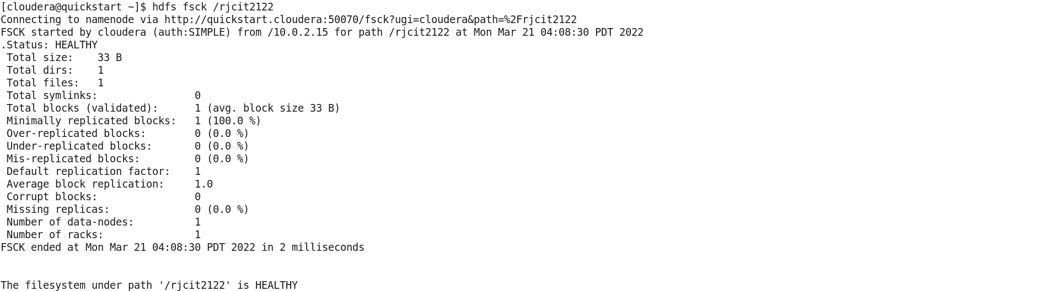

20)hdfs fsck /rjcit2122 -files

